**Notes temp**

Add multiple columns in a single axis

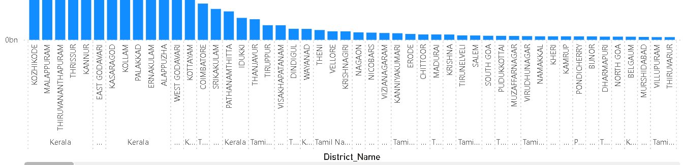

[Solved: Power BI Desktop - chart with two fields on x axis... - Microsoft Fabric Community](https://community.fabric.microsoft.com/t5/Desktop/Power-BI-Desktop-chart-with-two-fields-on-x-axis-timeline/td-p/2361067)